|  |  |
| --- | --- |
| SQL | NoSQL |
| Structured | Unstructured |
| Vertical scaling | Horizontal scaling |
| Less availability compared to NOSQL | Replica server makes it highly available |
| ACID property is supported | CAP theorem |
| Centralise server | Distributed |
| Joins are supported | No joins so we use nested documents |
| Speed is less as compared to no sql | Speed is high because of sharding |
| Table format | Document format or key value pair(JSON or BSON) |
| Supported Primary key | Supports primary key |
| Redundancy is less | Redundancy is more |
| Data is stored in table | Data is stored in collection |
| Records | document |

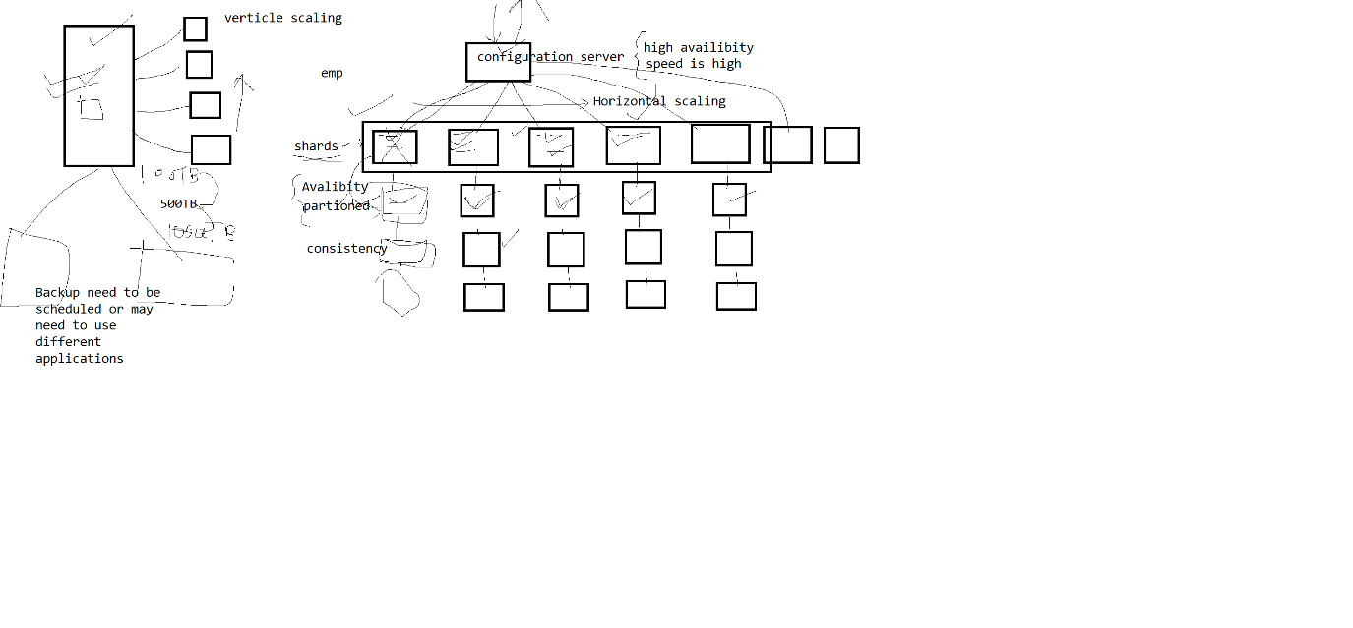

MYSQL

Storage engine

INNODB default storage engine if version >5.5

, MYISAM default storage engine if version < 5.5

INNODB—mostly used in transaction support

It supports row level line

This is the engine which supports foreign key

MYISAM

-stores the data in memory, good to use to store temporary table

-table level locking

MongoDB

WiredTiger.

set the path C:\Program Files\MongoDB\Server\5.0\bin

To start the server, use mongod and for client use mongo

c:\system34> mongod - -dbpath d:\data

to stop the server ^C

To client

open another command prompt

c:\system34>mongo

>

To see the databases

>show dbs

To create the data base or to change database

>use test

----to import data after –file write file path

mongoimport --db test --collection movie --file "D:\mongodb\Json Files\movie.json"

-----to export data

mongoexport --db test --collection movie --out "D:\mongodb\Json Files\employee.json"

to see the current database’

>db

|  |  |  |
| --- | --- | --- |
| show collections | To display all collections from current database |  |
| show dbs | Show all databases which has atleast one collection |  |
| use test | Will create database if not exists and change the database |  |
| db | To see the name od current database |  |
| db.student.insert | To add a record in existing collection or it will create a collection and then it will insert |  |
| db.createCollection | To create a empty collection |  |
| db.createCollection('myblogs',{capped:true,max:2,size:30000}); | To create capped collection |  |
| db.student.insertMany() | To add multiple documents |  |
| db.student.findOne() | To find single record |  |